MODULE 1
Prompt Engineering for Generative AI
In this module, you will learn the concept of prompt engineering in generative AI. You will also learn the best practices for writing effective prompts and assess common prompt engineering tools.
Learning Objectives

- Define a prompt and its key elements.
- Explain the concept and relevance of prompt engineering in generative AI.
- Apply the best practices for writing effective prompts to obtain the desired response.
- Explore commonly used tools for prompt engineering.
______________________________________________________________________________
Course Overview
Course Overview
Generative AI models are powerful, but their effectiveness depends on the quality of prompts used to guide them. This course is designed for practitioners, educators, and AI enthusiasts who want to master prompt engineering techniques and unlock the full potential of large language models (LLMs).
You will learn how to write effective prompts that control model outputs and generate precise, high-quality responses. Core techniques such as zero-shot and few-shot prompting will be covered, alongside advanced approaches like the interview pattern, chain of thought, and tree of thought. These strategies will help you improve reliability, relevance, and creativity when working with generative AI.
Throughout the course, you’ll engage with additional readings, expert insights, podcasts, and role-play activities that make the learning experience interactive and practical. You will also explore commonly used prompt engineering tools such as IBM watsonx Prompt Lab, Spellbook, and Dust, gaining familiarity with how professionals apply these tools in real-world contexts.
Hands-on labs in the IBM Generative AI Classroom provide opportunities to practice crafting prompts, test different approaches, and optimize results. By the end of the course, you will have both the theoretical knowledge and applied skills to design prompts that drive generative AI models to deliver impactful outcomes across a variety of use cases.
After completing this course, you will be able to:
- Explain the concept and relevance of prompt engineering in generative AI models
- Assess commonly used tools for prompt engineering
- Apply best practices for writing effective prompts
- Apply common prompt engineering techniques and approaches for writing prompts
Course Content
This course is divided into three modules. It is recommended that you complete one module per week or at a pace that suits you - whether it’s a few hours every day, or completing the entire course over a weekend or even in one day.
Week 1 - Module 1: Prompt Engineering for Generative AI
In this module, you will learn the concept of prompt engineering in generative AI. You will also learn the best practices for writing effective prompts and assess common prompt engineering tools.
Week 2 - Module 2: Prompt Engineering: Techniques and Approaches
In this module, you will discover techniques to craft prompts that effectively steer generative AI models. You will also learn about various prompt engineering approaches that can enhance the capabilities of generative AI models to produce precise and relevant responses.
Week 3 - Module 3: Course Quiz, Project and Wrap-Up
In this module, you will attempt a graded quiz that will test and reinforce your understanding of the concepts covered in the course. The module also includes a glossary to enhance your comprehension of generative AI-related terms. Finally, this module will guide you toward the next steps in your learning journey.
This module also includes optional topics related to text-to-image prompting and prompt engineering capabilities in IBM watsonx.
Learning resources
The course offers a variety of learning assets: podcast readings, interactive role-play activities, videos, hands-on labs, expert viewpoints, discussion prompts, and quizzes.
The concepts are presented through videos and readings, complemented by hands-on learning experiences in the labs.
Expert viewpoints are videos that feature industry practitioners showcasing real-world applications of the skills taught in this course.
Interactive learning is encouraged through discussions where you can meet your staff and peers.
Practice quizzes at the end of each module will test your understanding of what you learned. The final graded quiz will assess your conceptual understanding of the course.
Who should take this course?
This course caters to anyone eager to delve into the concept of prompt engineering and explore the various tools and approaches.
This course is for you if you are:
- An individual looking for an introduction to prompt engineering
- A student aiming to graduate with practical knowledge of writing effective prompts for generative AI models, thereby increasing job readiness
- A professional seeking to enhance your professional capabilities and efficiency by leveraging the capabilities of prompt engineering in generative AI
- A manager or executive keen on using prompt engineering for strategic advantages in your organization
Recommended background
This course is relevant for anyone interested in exploring the field of generative AI and requires no specific prerequisites.
The course uses simple, easy-to-understand language to explain the critical concepts of generative AI without relying on technical jargon. The hands-on labs provide an opportunity to practice the skills covered in the course and do not require a programming background or college degree.
To derive maximum learning from this course, all that’s needed is active participation in and completion of the various learning engagements offered throughout the modules.
Good luck!
______________________________________________________________________________
Specialization Overview
Specialization Overview
This course is part of multiple programs:
- Generative AI for Java and Spring Developers Specialization
- Generative AI for Project Managers Specialization
- Generative AI for Cybersecurity Professionals Specialization
- Generative AI for Software Developers Specialization
- Generative AI for Data Analysts Specialization
- IBM Generative AI Engineering Professional Certificate
- Generative AI for Data Scientists Specialization
- Generative AI for Educators Specialization
- Generative AI Fundamentals specialization
- Generative AI for Digital Marketing Specialization
- IBM AI Product Manager Professional Certificate
- Generative AI for BI Intelligence (BI) Analysts Specialization
- Generative AI for Human Resources (HR) Professionals Specialization
- AI Foundations for Everyone Specialization
- IBM AI Product Manager Professional Certificate
- Generative AI for Data Engineering Professional Certificate
- Generative AI for Mobile App Developers Specialization
- Generative AI for Program Managers Specialization
- Generative AI for Product Managers Specialization
- Generative AI for Customer Support Specialization
- Generative AI for Growth Marketing Specialization
- IBM AI Developer Professional Certificate
Generative AI Fundamentals specialization
This specialization provides a comprehensive understanding of the fundamental concepts, models, tools, and applications of Generative AI, empowering you to apply and unlock its possibilities.
In this specialization, you will explore the capabilities and applications of generative AI. You will learn about the building blocks and foundation models of generative AI. You will explore generative AI tools and platforms for diverse use cases. Additionally, you will learn about prompt engineering, enabling you to optimize the outcomes produced by generative AI tools. Further, you will gain an understanding of the ethical implications of generative AI in relation to data privacy, security, the workforce, and the environment. Finally, the specialization will help to recognize the potential career implications and opportunities through generative AI.
This specialization is intended for:
- Working professionals who want to enhance their careers by leveraging the power of generative AI
- Technophiles who wish to stay updated with the advancements in AI
- Individuals seeking an introduction to generative AI and a seamless experience through the world of Generative AI
- Managers and executives who want to leverage generative AI in their organizations
- Students who wish to graduate with practical AI skills that will enhance their job-readiness
Specialization Content
The Generative AI Fundamentals specialization comprises five short courses. Each course requires 4-6 hours of learners’ engagement time.
- Generative AI: Introduction and Applications
- Generative AI: Prompt Engineering Basics
- Generative AI: Foundation Models and Platforms
- Generative AI: Impact, Considerations, and Ethical Issues
- Generative AI: Business Transformation and Career Growth
Applied AI Professional Certificate
This professional certificate gives you a firm understanding of AI technology, its applications, and its use cases. You will also explore the capabilities and applications of generative AI. Additionally, you will learn about prompt engineering, enabling you to optimize the outcomes produced by generative AI tools.
You will become familiar with concepts and tools like machine learning, data science, natural language processing, image classification, image processing, IBM Watson AI services, OpenCV, and APIs. Even if you have no programming background, through this Professional Certificate, you will learn practical Python skills to design, build, and deploy AI applications on the web. The courses will also enable you to apply pre-built AI smarts to your products and solutions.
Certificate Content
The Applied AI Developer Professional Certificate includes the following courses:
- Introduction to Artificial Intelligence (AI)
- Generative AI: Introduction and Applications
- Generative AI: Prompt Engineering Basics
- Building AI Powered Chatbots Without Programming
- Python for Data Science, AI & Development
- Developing AI Applications with Python and Flask
- Building AI Applications with Watson APIs
Generative AI for Data Scientists Specialization
This specialization is designed to support individuals to kickstart their journey into applying generative AI in the field of data science. It caters to both current professionals and those aspiring to enter this field, encompassing roles such as data scientists, data analysts, data architects, engineers, and even individuals with a passion for working with data. In this specialization, you will understand the basics of generative AI and its real-world applications, learn about generative AI prompts engineering concepts and approaches, and explore commonly used prompt engineering tools, including IBM Watsonx, Prompt Lab, Spellbook, and Dust. Finally, you will also learn to apply generative AI tools and techniques throughout the data science methodology for data augmentation, data generation, feature engineering, model development, model refinement, visualizations, and insights.
Specialization Content
The Generative AI for Data Scientists Specialization includes the following courses:
- Generative AI: Introduction and Applications
- Generative AI: Prompt Engineering Basics
- Generative AI: Elevate your Data Science Career
Generative AI for Software Developers Specialization
This specialization is designed for anyone interested in leveraging the power of generative AI in software development. This specialization is suitable for both existing and aspiring web developers, mobile app developers, front-end developers, back-end developers, full-stack developers, DevOps professionals, and Site Reliability Engineers (SREs). You will learn the basics of generative AI including its uses, models, and tools for text, code, image, audio, and video generation, and explore various prompt engineering approaches and prompt engineering tools including IBM Watsonx, Prompt Lab, Spellbook, and Dust.
You will also boost your programming skills by learning to leverage generative AI to design, develop, translate, test, document, and launch applications and their code, and gain hands-on experience using generative AI tools and models, such as GitHub Co-pilot, Open AI ChatGPT, and Google Gemini, for various software engineering tasks.
Specialization Content
The Generative AI for Software Developers Specialization includes the following courses:
- Generative AI: Introduction and Applications
- Generative AI: Prompt Engineering Basics
- Generative AI: Elevate your Software Development Career
______________________________________________________________________________

What is a Prompt?
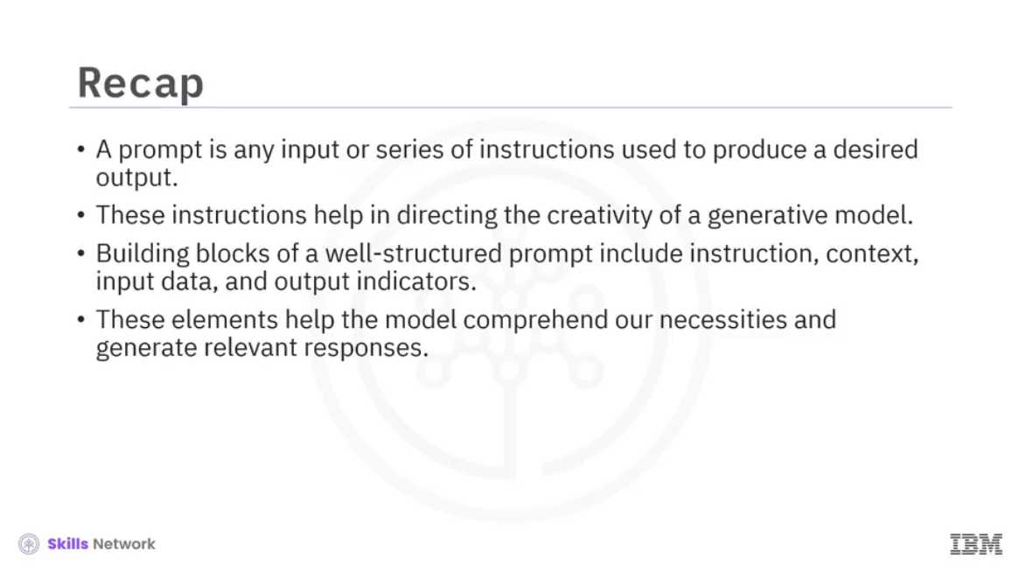
______________________________________________________________________________
What Is Prompt Engineering?
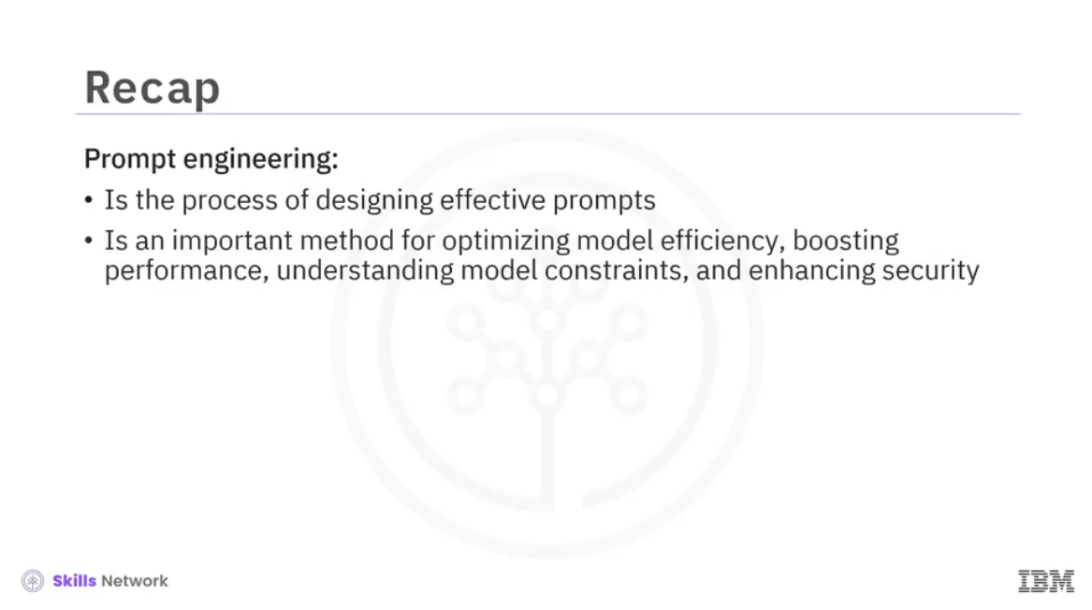
______________________________________________________________________________

Best Practices for Prompt Creation
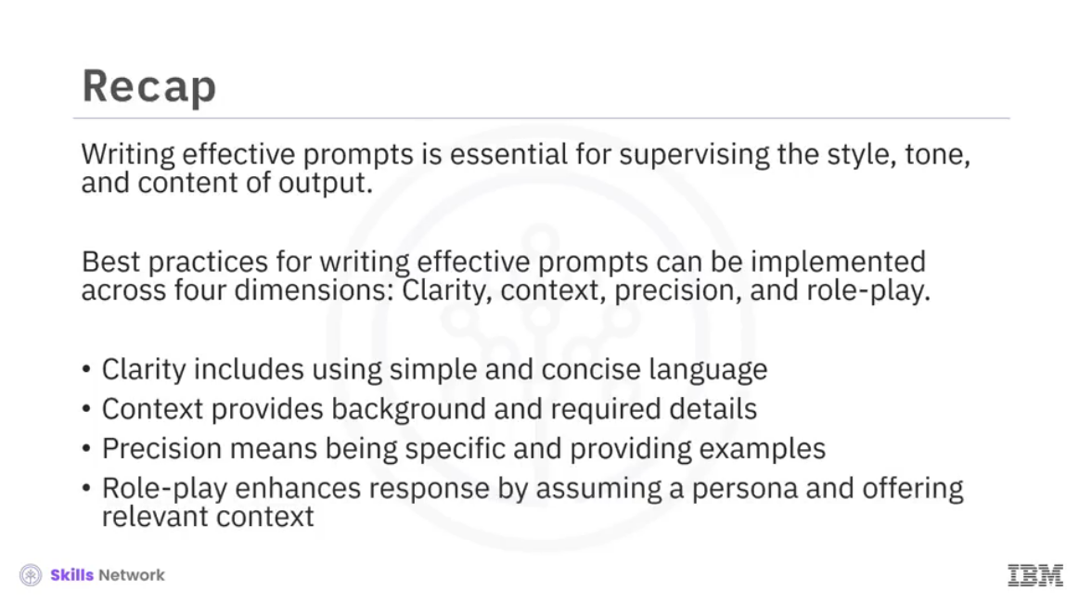
______________________________________________________________________________
Common Prompt Engineering Tools
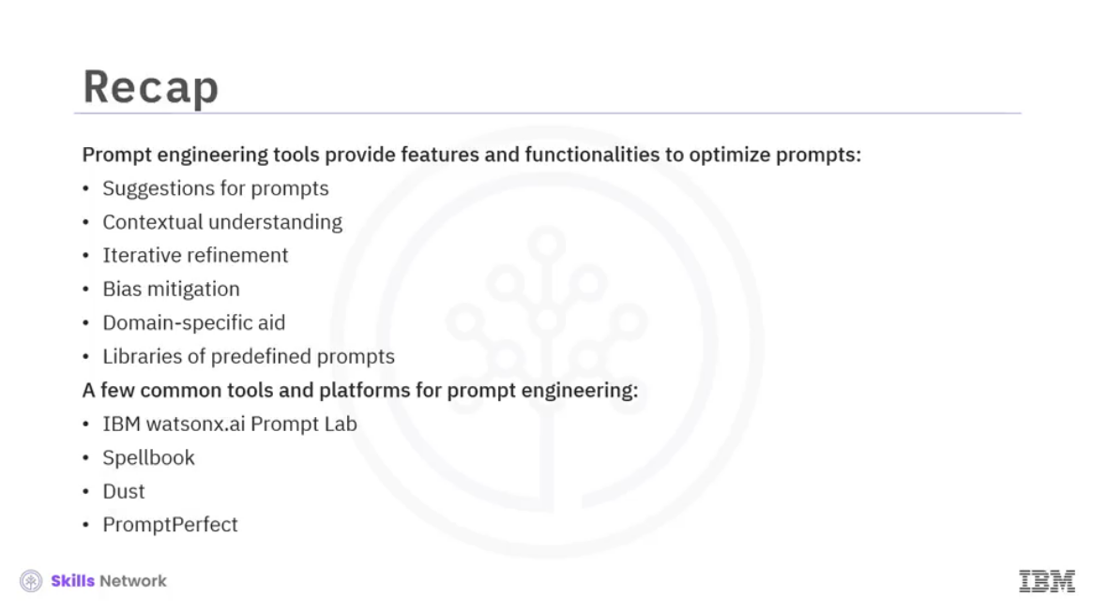
______________________________________________________________________________

Reading: Lesson Summary: Concept of Prompt Engineering
Congratulations! You have completed this lesson.
At this point, you have learned the concepts of prompts and prompt engineering in generative AI. You have also explored the best practices for writing effective prompts and some common prompt engineering tools.
You learned the definition of prompts and their elements. You were introduced to prompt engineering and its relevance to generative AI models. You learned the best practices for writing effective prompts and how to refine them. You learned the functionalities and capabilities of common prompt engineering tools. You even got the opportunity to experience creating prompts and learning about naive prompting and persona patterns through hands-on lab experiences. You were privy to what experts from the field had to say about prompt engineering.
Specifically, you learned that:
- A prompt is any input or a series of instructions you provide to a generative model to produce a desired output.
- These instructions help in directing the creativity of the model and assist it in producing relevant and logical responses.
- The building blocks of a well-structured prompt include instruction, context, input data, and output indicators.
- These elements help the model comprehend our necessities and generate relevant responses.
- Prompt engineering is designing effective prompts to leverage the full capabilities of the generative AI models in producing optimal responses.
- Refining a prompt involves experimenting with various factors that could influence the output from the model.
- Prompt engineering helps optimize model efficiency, boost performance, understand model constraints, and enhance its security.
- Writing effective prompts is essential for supervising the style, tone, and content of output.
- Best practices for writing effective prompts can be implemented across four dimensions: clarity, context, precision, and role-play.
- Prompt engineering tools provide various features and functionalities to optimize prompts.
- Some of these functionalities include suggestions for prompts, contextual understanding, iterative refinement, bias mitigation, domain-specific aid, and libraries of predefined prompts.
- A few common tools and platforms for prompt engineering include IBM watsonx Prompt Lab, Spellbook, Dust, and PromptPerfect.
______________________________________________________________________________

